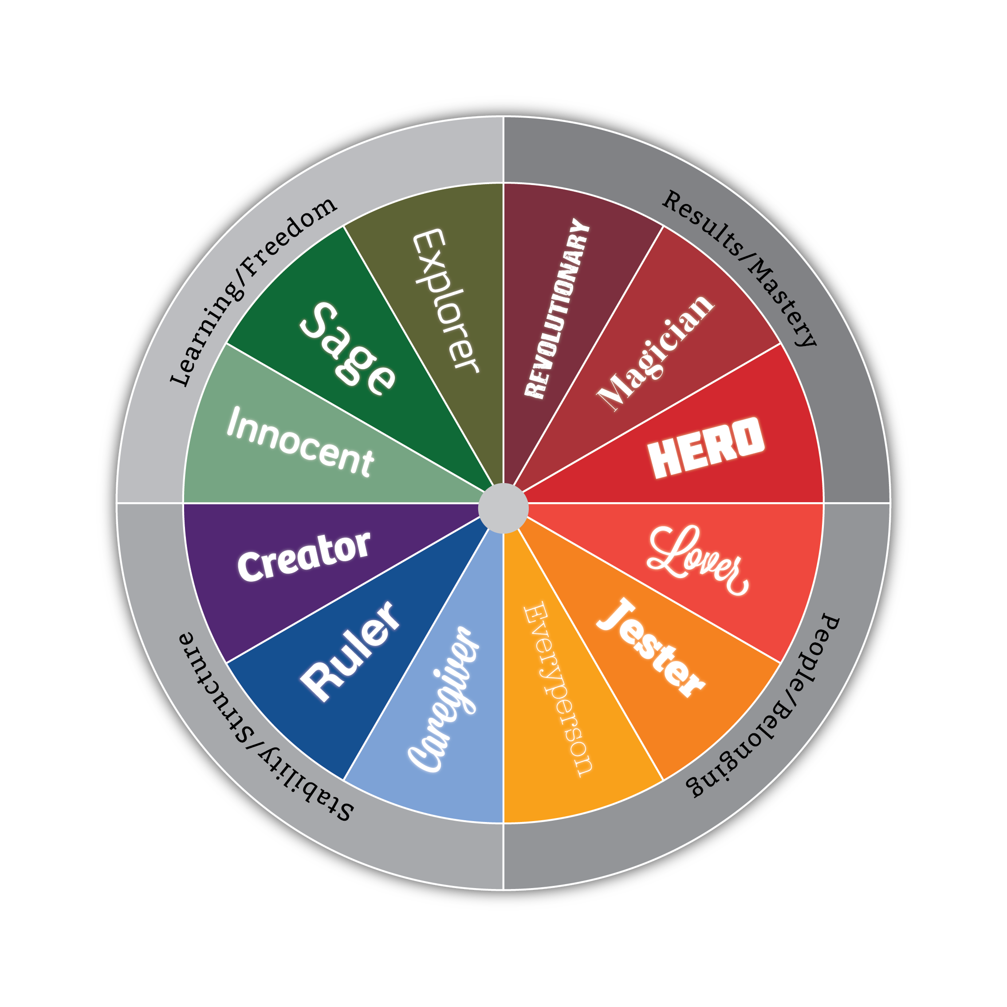

Archetype

**Character**

**Archetypes**

**Common**

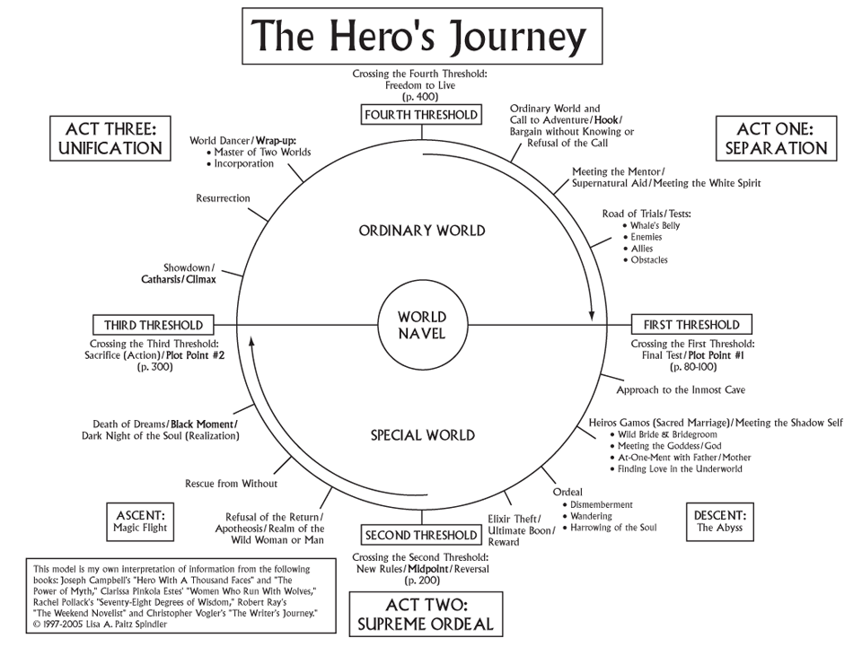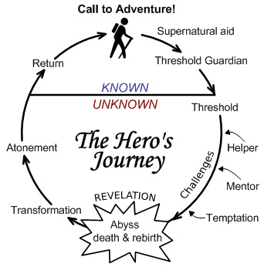

|  |  |
| --- | --- |
| **Examples from Film or Literature** | |
| **Hero** |  |
| **Lover** |  |
| **Sage** |  |
| **Caregiver** |  |
| **Innocent** |  |
| **Ruler** |  |

An Archetype is ______________________________

_________________________________________________________________________________________________________________________________

Archetype