Creativity Activities
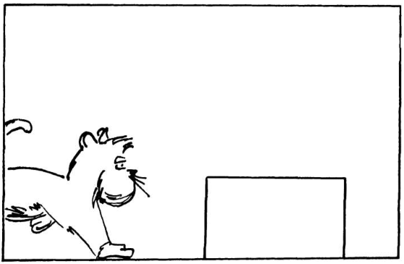
Using the lines below, write the story depicted in the picture.

______________________________________________________________________________

Without picking up your pencil and using only four straight lines, connect all nine dots.

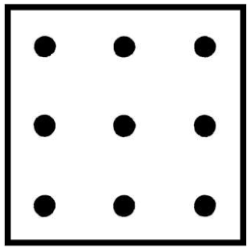
Find the star.
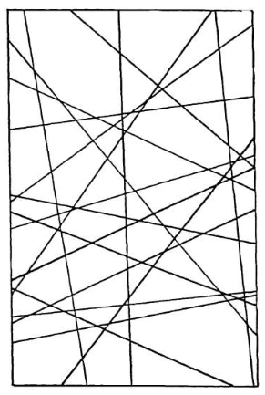

The woman in the picture needs to join the strings together, but she can’t reach them both at the same time. How can she solve her problem?
